STATE OF KANSAS

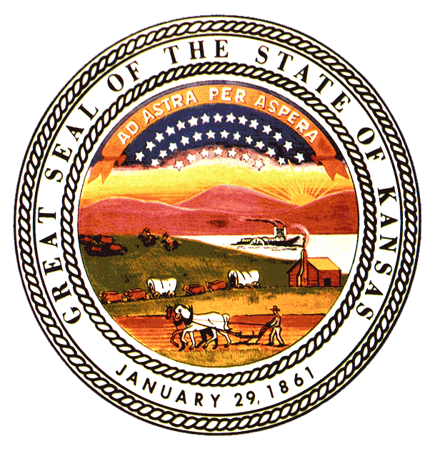

PROCLAMATION OF PARTNERSHIP
Between the 184th Wing, Kansas Air National Guard,
and the Kansas Association of Community Colleges
WHEREAS, the 184th Wing of the Kansas Air National Guard is committed to sustaining a highly skilled, mission-ready force capable of meeting the evolving demands of national defense, homeland security, and emerging technologies; and
WHEREAS, the Kansas Association of Community Colleges (KACC) represents institutions dedicated to providing accessible, high-quality education and workforce development opportunities that strengthen Kansas communities and advance the state’s economic vitality; and
WHEREAS, both the 184th Wing and KACC recognize that a strong, future-focused partnership between military and educational institutions enhances the readiness of the Kansas Air National Guard, expands opportunities for Kansas learners, and supports the long-term resilience of the state’s workforce; and
WHEREAS, the parties share a mutual interest in developing academic pathways, technical training, and professional development programs that align with the operational needs of the 184th Wing, including but not limited to cybersecurity, intelligence analysis, information technology, aviation maintenance, emergency management, logistics, and emerging mission areas; and
WHEREAS, the community colleges of Kansas are uniquely positioned to expand curriculum, credentials, and applied learning opportunities that reflect real-world mission requirements, while the 184th Wing possesses deep subject matter expertise, operational insight, and instructional capability that can enrich academic programs statewide; and
WHEREAS, this partnership will strengthen Kansas’s talent pipeline, enhance educational access for Airmen and civilians alike, and reinforce the shared commitment of both entities to serve the people of Kansas with excellence, integrity, and innovation.
---
NOW, THEREFORE, WE DO HEREBY PROCLAIM THAT:
1. Establishment of a General Partnership
The 184th Wing and the Kansas Association of Community Colleges formally enter into a collaborative partnership to advance educational, technical, and workforce development initiatives that benefit both organizations and the State of Kansas.
2. Curriculum Expansion and Alignment
KACC member institutions will work collaboratively with the 184th Wing to expand, adapt, or develop curriculum and credentialing pathways that reflect the Wing’s current and emerging mission needs.
3. Subject Matter Expertise and Instructional Support
The 184th Wing will provide subject matter experts to assist in curriculum development, program design, guest instruction, applied learning experiences, and other academic support activities as mutually agreed upon.
4. Shared Commitment to Innovation and Excellence
Both parties will pursue innovative approaches to education and training, including stackable credentials, competency-based learning, micro-pathways, and opportunities that support Airmen, veterans, and Kansas learners seeking technical and professional advancement.
5. Ongoing Coordination and Evaluation
The parties will establish regular communication channels to review progress, identify new opportunities, and ensure that programs remain aligned with mission requirements, workforce needs, and student success outcomes.
---
IN WITNESS WHEREOF,
The undersigned affirm their commitment to this partnership and to the advancement of educational excellence, workforce readiness, and service to the State of Kansas.

Signed this 11 day of February 2026.

______________________________ ______________________________
Commander, 184th Wing Executive Director
Kansas Air National Guard Kansas Association of Community Colleges

